Results: Data and Characterization

The purpose of this chapter is to present both the results of design and fabrication work (in pictorial form) and the resultant data obtained from testing (in the form of graphs and tables). As such, this chapter is divided into three sections: Section A describes design and fabrication, Section B describes experimental testing data, and Section C describes output from impedance analyzer testing.

Tables of raw data may be found in the Appendix.

SECTION A

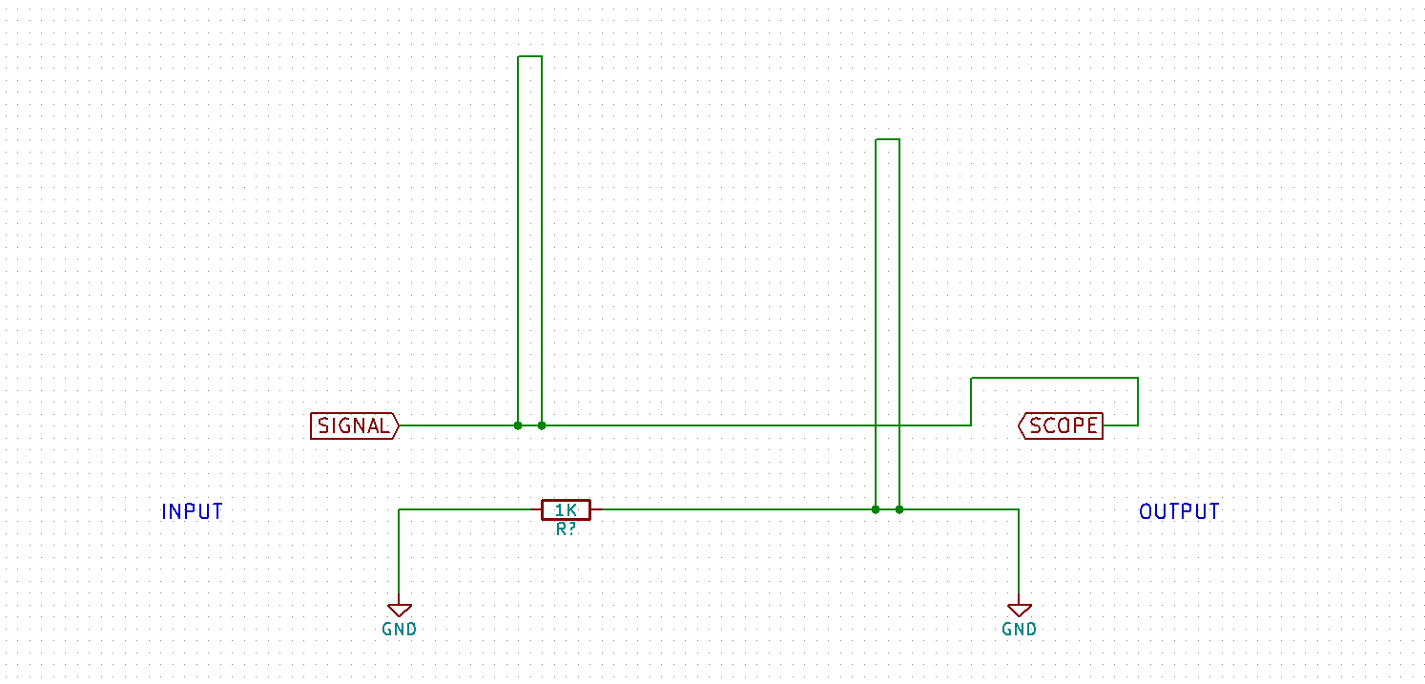

Figure 0.1: Physical layout of the sensor

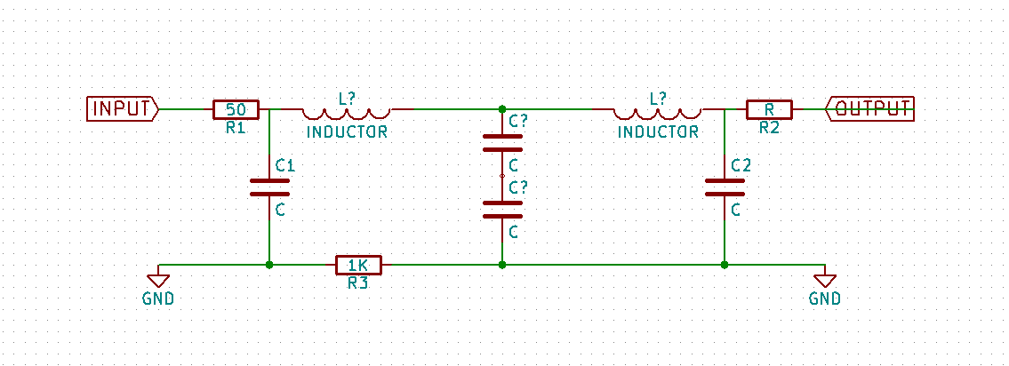  
Figure 0.2: Theoretical lumped-element schematic

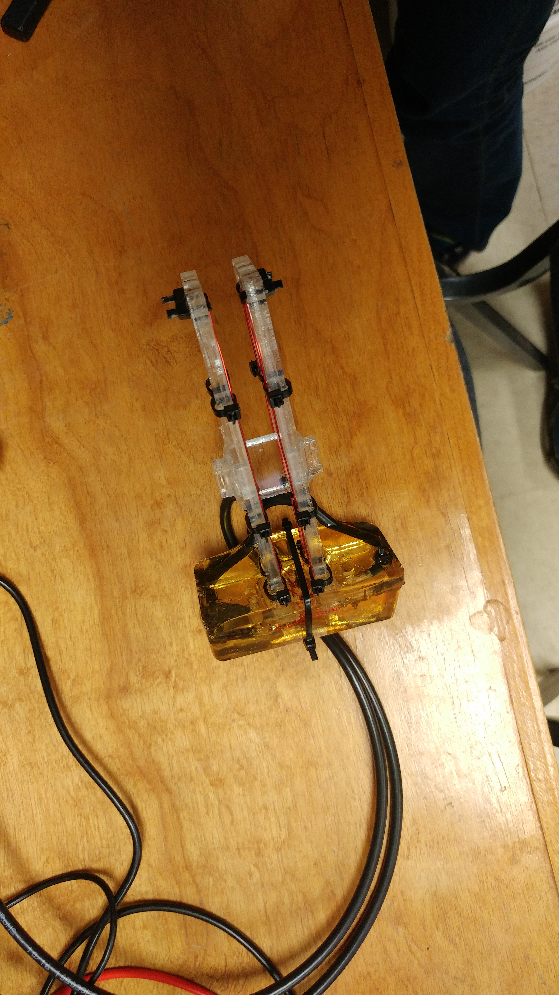

Figure 0.3: Photograph of actual prototype sensor. Main components of the sensor can be easily identified: the yellow transparent block contains connections between the legs of the sensor (orange wire on transparent plastic) and the input and output coaxial cables (black cables to the left).

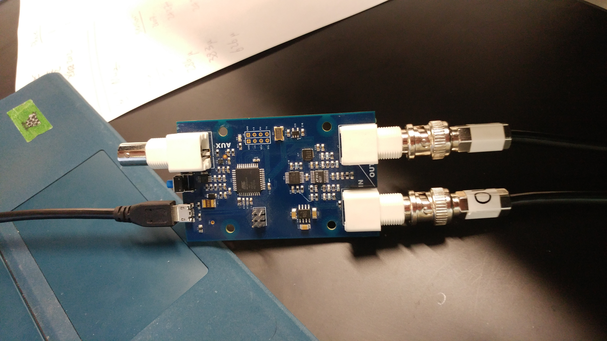

Figure 0.4: Tsunami board. The input and output connections to the sensor can be seen on the right side of the board. The connector on the upper left is an unused trigger output. Power is supplied to the board via a 5V usb connection on the lower left.

SECTION B

Figure 1.0: Sensor output in millivolts dependent on water specific conductivity in microSiemens/centimeter. This data was obtained using code version 1 and a probing frequency of 1.52 Mhz.

Figure 1.1: Sensor output in millivolts dependent on water specific conductivity in microSiemens/centimeter. This data was obtained using code version 1 and a probing frequency of 1.52 Mhz.

Figure 1.2: Sensor output in millivolts dependent on water specific conductivity in microSiemens/centimeter. This data was obtained using code version 1 and a probing frequency of 1.52 Mhz.

Figure 2.0: Sensor output in millivolts dependent on water specific conductivity in microSiemens/centimeter. This data was obtained using code version 1 and a probing frequency of 1.0 Mhz.

Figure 3.0: Sensor output in millivolts dependent on water specific conductivity in microSiemens/centimeter. This data was obtained using code version 1 and a probing frequency of 0.8 Mhz.

Figure 4.0: Comparison of sensor output in millivolts dependent on water specific conductivity in microSiemens/centimeter using 1.52 Mhz, 1 Mhz, and 0.8 Mhz probing frequencies. This data was obtained using code version 1. The three datasets were obtained sequentially, not concurrently.

Figure 4.1: Comparison of sensor output in arbitrary units dependent on water specific conductivity in microSiemens/centimeter using 1.52 Mhz , 1 Mhz, and 0.8 Mhz probing frequencies. This data was obtained using code version 1. The two datasets were obtained sequentially, not concurrently. The data for 1 Mhz and 0.8 Mhz measurements has been baseline adjusted using the 1.52 Mhz data. Data point icons have been removed for clarity.

Figure 5.0: Comparison of sensor output in millivolts dependent on water specific conductivity in microSiemens/centimeter using 1.52 Mhz and 0.8 Mhz probing frequencies. This data was obtained using code version 2. The two datasets were obtained concurrently. The data has not been adjusted in any way.

Figure 5.1a: Comparison of sensor output in arbitrary units dependent on water specific conductivity in microSiemens/centimeter using 1.52 Mhz and 0.8 Mhz probing frequencies. This data was obtained using code version 2. The two datasets were obtained concurrently. The data for 0.8 Mhz measurements has been baseline adjusted using the 1.52 Mhz data. Data point icons have been removed for clarity.

Figure 5.1b: Same as 5.1a, but with logarithmic x-axis

SECTION C



D

C

B

A

Figure 6.0: Duplicate of Figure 0.2 with added labels to notate test points

Figure 6.1: Impedance measured across the ground shield of the sensor, between point C and point D.

Figure 6.2: Impedance measured across the center conductors of the input and outputs, between point A and point B.

Figure 6.3: Impedance measured across the center conductor and shield of the sensor input, between point A and point C.